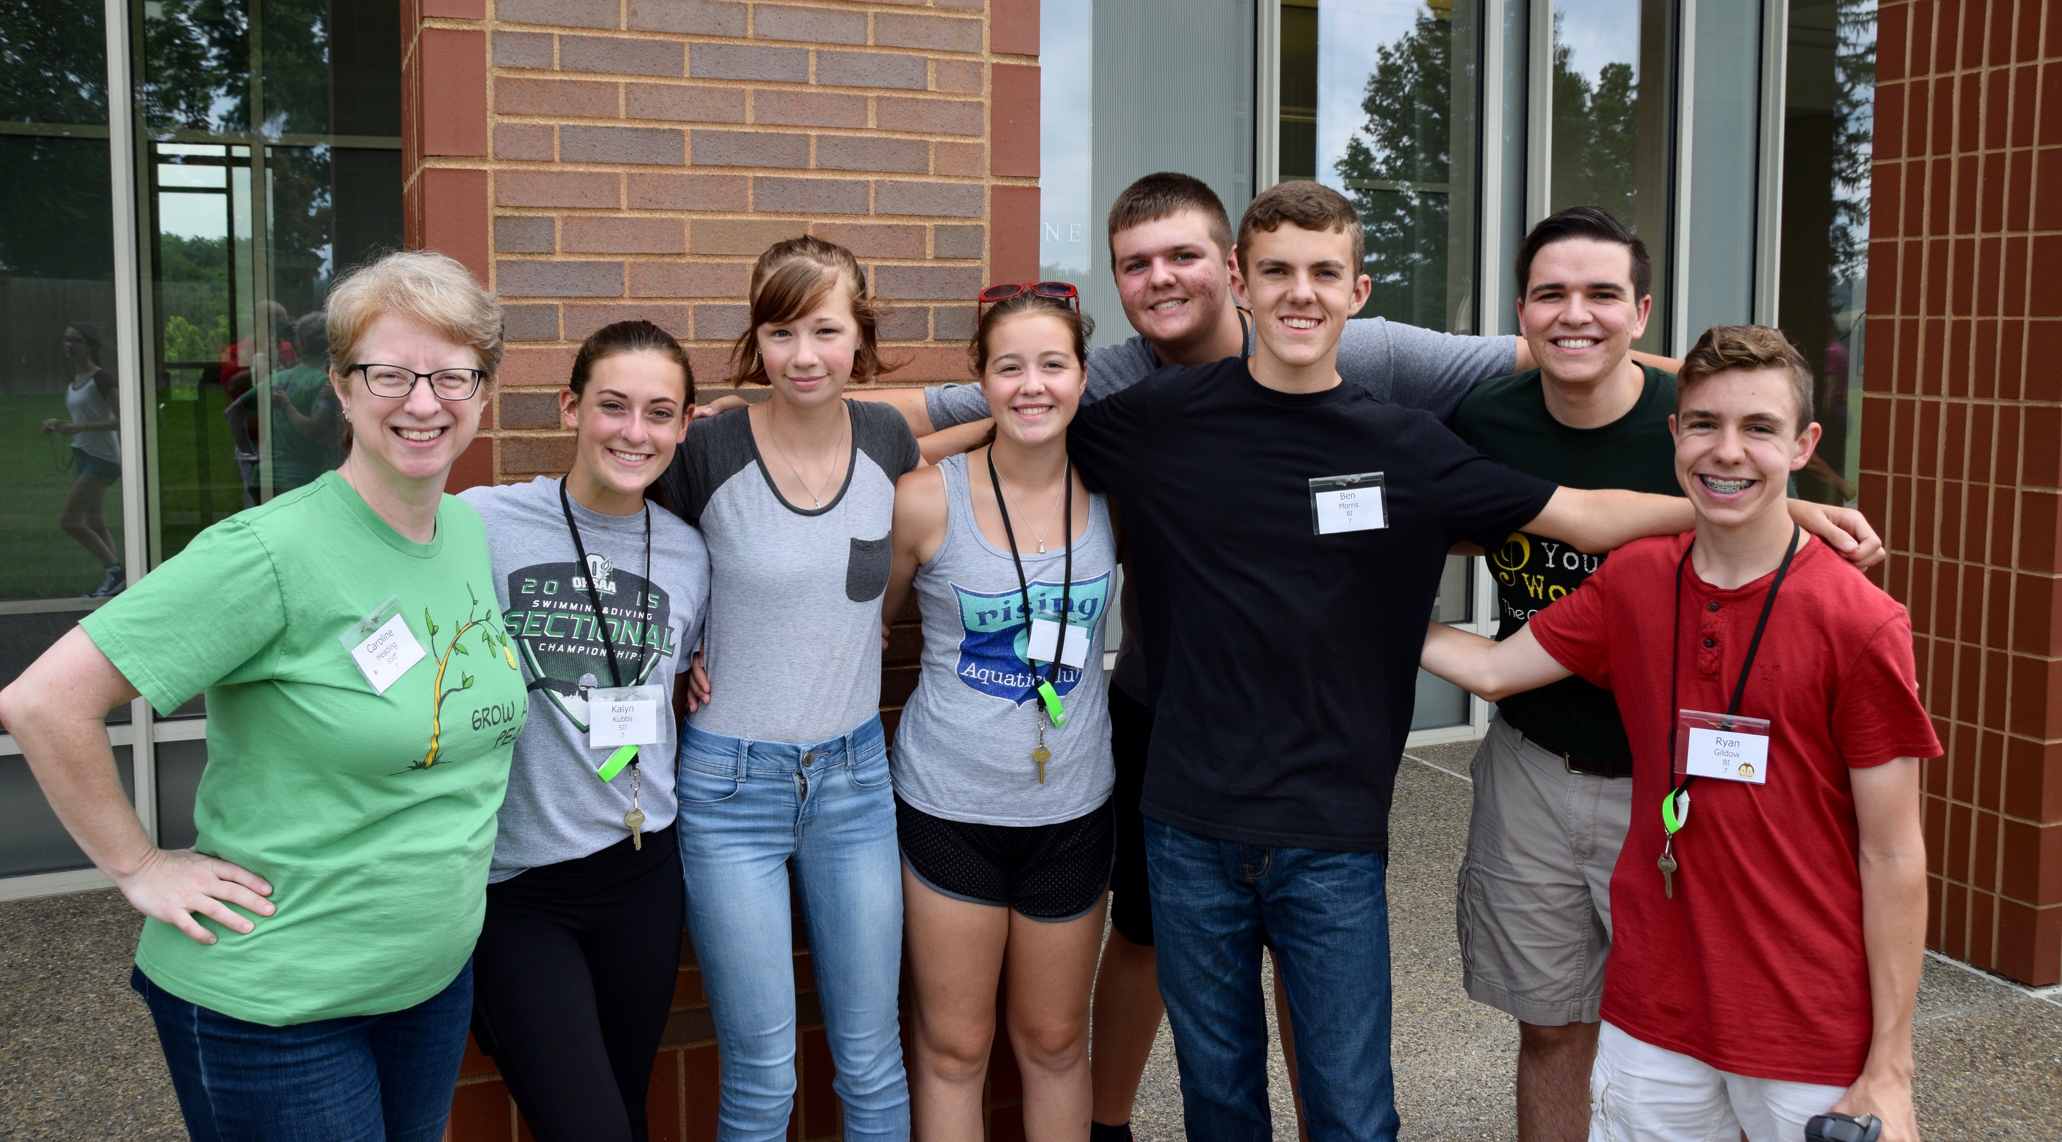
The Cardinal Chorale
- Choral Ambassadors of Hope -

Touching hearts and changing lives, one song at a time

Monday, 2 July, 2018

Dear Friends of the Cardinal Chorale,

It was good to see many of you on our June tour! Primed and empowered by our successful OMEA performance on February 10, we set out on tour with energy and joy. We traveled 750 miles: to Marion, Lewis Center, Columbus, Lakeside, Fostoria, New Concord, and Roscoe Village. We shared love, laughter, faith and hope as we sang for appreciative audiences in small and large churches, in retirement villages and care centers, and for surprised visitors and staff at the John Glenn museum, the Polaris Food Court, along the streets of Lakeside, and at the Marblehead lighthouse. Over 1,300 listeners enjoyed our 58 songs, sung in 10 concerts and 10 impromptu performances.

After our first concert in Marion, a listener exclaimed, “Wow! Amazing! It was my first time to hear the Chorale, and I was completely blown away by the musical talent. What an exceptional group of young people! The title was Give Us Hope, and that was certainly accomplished. I was especially impressed with the music selections. The concert made my week. To say the least, you are a breath of fresh air, and so needed during these challenging times.”

When I wrote to many of you a year ago, the need was great: we knew we needed at least $16,500 to provide need-based scholarships for the Workshop, as well as housing and meals for our all-volunteer staff. But you opened your hearts and your wallets, and your gifts of $19,680 provided significant scholarships for 65% of the 23rd Chorale’s singers. A generous grant from the Charles E. and Dorothy S. Bechtol Fund of the Coshocton Foundation also helped with scholarships, made evening concerts possible for the Workshop, and provided our first music performance folders.

This year’s Cardinal Chorale Music Workshop – our fourth - will be held on the campus of Muskingum University, Saturday, July 21 through Saturday, July 28. The cost will again be an all-inclusive $495. You may be interested to know that similar week-long music/art camps are $700 - $1,500, with $900 being the average. We’re able to operate with the $495 fee largely due to your gifts for scholarships, and because the entire staff volunteers their time.

The singer fees pay for their room and board at Muskingum, uniform polos and tee shirts, and their music and rehearsal CDs. We’re estimating that we’ll need to raise at least $18,000 for need-based scholarships this year.

Once again we are asking for your help. Any gift will be gratefully received and will be used to cover program expenses for singers in need, and to pay for food and housing for our experienced and dedicated staff. While singers will personally benefit from the educational, musical, and social experiences they will receive as part of the Cardinal Chorale Music Workshop, your gift is also an investment in the future of the Cardinal Chorale, our choral ambassadors of hope.

Gifts may be made on our website: www.thecardinalchorale.com or mailed to: The Cardinal Chorale, P.O. Box 27, Coshocton, OH 43812. Checks may be made payable to: The Cardinal Chorale. If you have questions, please feel free to contact us by email: thecardinalchorale@gmail.com or by telephone: 740/623-0554.

Over the years, one of my personal heroes has been Mister Rogers, and I’m looking forward to seeing “You Are My Friend,” the new movie about his life. Fred Rogers, Presbyterian minister and pioneer in children’s television, wrote, “We live in a world in which we need to share responsibility. It’s easy to say, ‘It’s not my child, not my community, not my world, not my problem.’ Then there are those who see the need and respond. I consider those people my heroes.”

Thank you for the life-changing difference you are making, dear friends!

Gratefully, Check our website to read the blog from our recent tour.
Search Cardinal Chorale on YouTube to see some videos
featuring pictures and music from recent tours and from
last year’s Chorale Workshop.
Charles R. Snyder
For the singers and staff of the 24th Cardinal Chorale

